Business Management
Pre and Post Test
- What is the difference between vertical and horizontal business integration? 3.3 Management

- Who is in charge of day to day business operations? 3.3 Management
  - Business Director
  - Manager
  - Executive Board
  - Employees

- It is important to set what when operating a business? 3.3 Management
  - Goals
  - Timelines
  - Benchmarks
  - Budget

- The main objective of sales is to supply the needs of whom? 3.2 Sales and Customer Service
  - The salesman
  - The employers
  - The customer
  - The economy

- The transaction that occurs when someone exchanges services or goods for a valuable medium such as money is called __________________. 3.2 Sales and Customer Service

- Prospecting in sales is a term used to describe 3.2 Sales and Customer
  - Someone who is mining for rare minerals
  - Activities to identify new accounts
  - Searching for detailed product information
  - Using open ended questions to get good personal info on a customer

- What is the acronym used to set goals? 3.7 Communication Skills
  - SMART
  - SALES
  - GOALS
  - OTES

- Why would a business write a mission statement? 3.3 Management

- What is the difference between a cash flow and a budget? 3.4 Finance

- What is the form that every person in the US receives to file their taxes? 3.4 Finance
  - 1099
  - 401K
  - W2
  - 3.14

- What is the day that all income taxes are due to be filed with the federal government? 3.4 Finance
  - April 1th
  - April 30th
  - April 15th
  - January 1st

- Explain the difference between gross and net income? 3.4 Finance

- Which one of the following would be a capital expense? 3.5 Purchasing and Inventory

  - Feed
  - Seed
  - Market Livestock
  - Land

- What is done to prevent cross contamination between farms? 3.12 Argo-security and biosecurity
  - Wash in and wash out
  - Burning Clothes
  - Stop, drop and roll
  - Nothing needs to be done

- Describe the difference between sole proprietorship and partnership. 3.10 Business Regulation, Law and Related Issues

- What types of business has the most risk? 3.10 Business Regulation, Law and Related Issues

  - Sole Proprietorship
  - Partnership
  - Cooperative
  - LLC

- Name one method of keeping record keeping. 3.6 Information Management

- What is used to keep business meetings organized? 3.8 Business Leadership
  - Constitution
  - By Laws
  - Agenda
  - Parliamentary Procedure

- Give an example of appropriate attire to wear to a business interview. 3.9 Emotional Intelligence

- Which of the following is not included on a resume? 3.7 Communication Skills
  - Social Security Number
  - Name and address
  - Education
  - Special Skills and Experience

- What type of insurance do you need in case a family member gets ill? 3.4 Finance
  - Auto
  - Health
  - Home
  - Liability

- Give two examples of why feed costs would fluctuate? 3.1 Marketing

- One would expect the greatest rise in demand when… 3.1 Marketing

  - Demand increase and supply increases
  - Demand decrease and supply increases
  - Demand increases and supply increases
  - Demand increase and supply increase

- At what time would expect the cost of corn to be at its highest? 3.5 Purchasing and Inventory
  - Summer
  - Fall
  - Spring
  - Winter

- True or False A farmer can sell their crops before they have been planted. 3.1 Marketing

- Which of the following is not specified in a futures contract? 3.1 Marketing

  - Commodity
  - Delivery Point
  - Delivery Date
  - Price

- What is the size of a crop contract? 3.1 Marketing
  - 10,000 bu
  - 1,000 bu
  - 1 bu
  - 5,000 bu

Use chart b to answer the following questions.
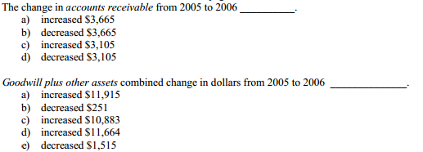
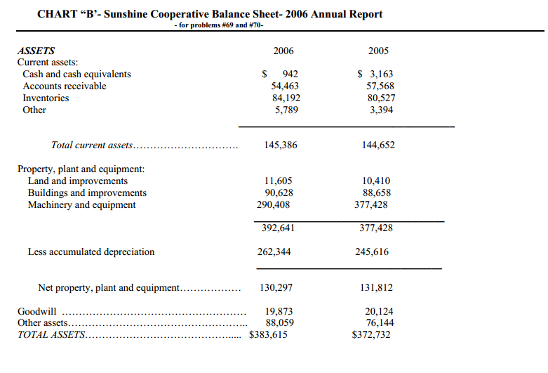
28.

29.

30. When a farmer decides to grow Soybeans as well as corn and raise livestock it is called _____.
a. Specialization
b. Diversification
c. Sole Business
d. Variation

