Plant Sciences
Pre/Post Test

- An example of organic matter in the soil is _______________. (Soil Sciences)
  - Water
  - Footprints
  - Dead leaves
  - Layers

- When a plant is at wilting point, there is no soil moisture. (Soil Sciences)
  - True
  - False

- Mottling in the soil is a key indicator of __________________ in the soil? (Soil Sciences)
  - Wetness
  - Dryness
  - Organic Matter
  - High Nutrient Content

- Name the three soil particles from smallest to largest. (Soil Sciences)

- Hydroponics is the process of growing plants without _________________. (Hydroponics)
  - Nutrients
  - Sun
  - Water
  - Plants

- In a hydroponics system, what is not important to test? (Hydroponics)
  - pH
  - Nitrogen level
  - Phosphorus level
  - Cobolt level

- What plant part anchors the plant as well as absorbs water for plant? (Anatomy)
  - Leaves
  - Stems
  - Roots
  - Flower

- What part of the plant is responsible for the new growth of a plant? (Anatomy)
  - Cambium
  - Mesophyll
  - Epidermis
  - Bark

- One bushel of corn = _____ pounds (Anatomy)
  - 64
  - 52
  - 56
  - 78

- One bushel of beans = _____ pounds (Anatomy)
  - 52
  - 60
  - 64
  - 78

- IN detail, please describe the path that pollen takes in order to produce a seed. To receive full points, you must use vocabulary words associated with parts of the plant. You may use pictures or diagrams to help explain. (Anatomy)

- A potato is a stem. (Anatomy)
  - True
  - False

- Deciduous plants lose their leaves (Taxonomy)
  - True
  - False

- Please list two differences between monocots and dicots. (Taxonomy)

- An example of a monocot is __________________. (Taxonomy)
  - Corn
  - Soybeans
  - Sunflowers
  - None of the above

- The three top macronutrients needed by plants are…. (Growing)
  - Nitrogen, Magnesium, and phosphorus
  - Potassium, colbolt, and oxygen
  - Nitrogen, potassium, magnesium
  - Nitrogen, potassium, phosphorus

- The pH scale ranges from ____-_____. (Growing)
  - 0-20
  - 1-5
  - 10-20
  - 0-14

- Most plants prefer a pH balance of ____. (Growing)
  - 1
  - 5
  - 7
  - 16

- A fertilizer label that has 20-15-0 marked on the side has what percentage of nitrogen? (Growing)
  - 20%
  - 15%
  - 0%
  - You can’t tell from the label

- Plant reproduce _________________. (Reproduction)
  - Sexually
  - Assexually
  - Neither a or b
  - Both a and b

- The female part of a plant is called a ____________ and a male part is called a _____________. (Reproduction)
  - Pistil, stamen
  - Stamen, pistil
  - Ovary, style
  - Flower, stem

- Please list three abiotic factors that affect plant growth and reproduction. (Reproduction)

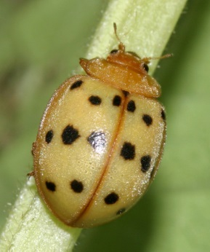
- What is this pest? (Pest Management)
  - Ladybug
  - Aphid
  - Armyworm
  - Mexican Bean Beetle

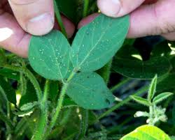
- What is this plant? (Pest Management)
  - Beans
  - Alfalfa
  - Barley
  - Beans
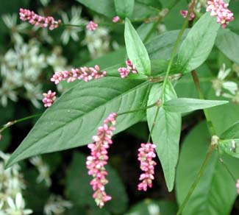
- What is this weed? (Pest Management)
  - Giant Ragweed
  - Tall Fescue
  - Smartweed
  - Nightshade

- Which weed is in the potato family and is poisonous? (Pest Management)
  - Giant Ragweed
  - Tall Fescue
  - Smartweed
  - Nightshade

- Please list the four strokes of a four stroke engine.

- In a four stroke engine, during the combustion stroke, both valves are closed.

- PTO stands are ________________ take _______________.

- How many rotations does it take the camshaft to turn in order to complete all four strokes?
  - 180 degrees
  - 360 degrees
  - 420 degrees
  - 720 degrees

